**CHAPTER 1:- INTRODUCTION**

* 1. **Company Profile:**

Net Flex Software Technologies is the fastest growing IT company, which works on the basic principles of Accelerating Business Growth, lowering Costs, and Mitigating Risks. And believes in Organization must continuously innovate and transform themselves to stay ahead of competition.

We are building the world’s most competitive consulting firm. Delivering high quality business consulting and disciplined technology implementation at an extremely competitive price

Net Flex Software Technologies provides application and IT outsourcing to mid-market companies that have chosen packaged applications.

We share the vision of a borderless global marketplace enabled by the Internet and its convergence with other media.

We continue to impress upon all businesses, clients and non-clients, the enormous possibilities of dramatically improving their efficiency, customer satisfaction and expanding their customer base while significantly reducing their overall costs through applications of Information Technologies.

Entrepreneurial Leadership: We aim at breaking into the golden circle of the globally acclaimed Information Technology Services companies. This can be done through the achievement of sustainable and profitable growth through delivery of exceptional IT services to customers.

Customers Leadership: We want to be the no. 1 choice for all our clients and customers. As a company of outstanding people who care for our customers, we take pride in the quality of our services, our business ethics, and are passionate about winning.

* 1. **Existing System and Needs of System:**

The Existing System of packers and movers are work a manually and paper work. The billing system are not work properly. Also now these system application is widows based so customer need not get proper service. Online system is use in cloud environment.

* It is time consuming.
* It consumes lot of men power to better results.
* It lacks of data security.
* Retrieval of data takes lots of time.
* Percentage of accuracy is less.
* Reports takes time to produce.

Packers and Movers is an online platform for service seekers and service providers where all the companies are available at single site as web portal and they do communicate directly with service seekers. In Packers and Movers we have listed excellent packing moving service providers of India, household shifting and relocation services providers, car transportation, office relocation, home, shop, industrial or commercial shifting service providers of India. Our packers and movers directory is having ultimate objective of providing information to its visitors about best packers movers and relocation companies offering its services in Indian destinations. The reliable and swift packers and movers services providers are the best for any kind of relocation and car transportation services.

* 1. **Scope of Work:**

The scope of this Project is to give and interactive platform for clients and different Packing and Moving Companies so that a best and reliable service is provided through this Web Portal. This Portal also giving useful information to users and companies that help them a lot.

This is a web based application so it is having much scope over the internet. It helps to provide best and reliable services to clients. All the small scale and big scale companies can access it and may spread their organization to worldwide.

1. In this web application the administration can manage the whole service of the packers and movers also admin can manage the all companies agents, company transportation, quotation and feedback of clients.
2. Here the agent can update his profile and also see the customer quotations.
3. The Customer can give the quotation and Feedback to the organization.
4. The Admin Can be Insert, Update, Delete and Show the Reports of organization data.
   1. **Operating Environment-Hardware and Software:**

**The Client Machine (**Minimum Requirement**)**

1. Processor **:** Intel Pentium IV and above
2. RAM **:** 1 GB
3. Hard Disk **:** 40 GB
4. Operating System **:** Windows XP/7/8/10
5. Browser **:** Mozilla Firefox 12.0 & above

Chrome 20.0 & above

**The Server Machine (**Minimum Requirement**)**

1. Processor **:** Intel Pentium IV and above
2. RAM **:** 2 GB
3. Hard Disk **:** 40 GB
4. Operating System **:** Windows XP/7/8/10
5. Database **:** MYSQL

**The Development Environment**

1. Development End **:**Net beans 7.2.1
2. Front End **:**JavaScript, CSS, HTML
3. Operating System **:** Windows XP/7/8/10
4. Database **:** MYSQL
5. Browser **:** Mozilla Firefox 12.0 & above

Chrome 20.0 & above

**1.5 Detail Description of Technology Used**

**About JAVA:**

Java is a programming language originally developed by James Gosling at Sun Microsystems (which is now a subsidiary of Oracle Corporation) and released in 1995 as a core component of Sun Microsystems' Java platform. The language derives much of its syntax from C and C++ but has a simpler object model and fewer low-level facilities. Java applications are typically compiled to byte code (class file) that can run on any Java Virtual Machine (JVM) regardless of computer architecture. Java is general-purpose, concurrent, class-based, and object-oriented, and is specifically designed to have as few implementation dependencies as possible. It is intended to let application develop write once, run anywhere". Java is considered by many as one of the most influentially programming languages of the 20th century, and is widely used from application software to web applications

The most important and powerful feature of java as a programming language is that it is platform independent. The term platform independent means that java doesn't need specific vendor oriented platform to run. It can be run on any of the existing platforms and would produce the same output. Thus, whether I run java on windows, UNIX, Linux or Macintosh, I would get the same desired result. Contrast this with .net which can only be used with windows. So, java is the only option we are left with for developing web based application. This is because internet is a network of millions of computers having different types of hardware and software. So, we definitely need a platform independent, easy to understand language to develop web based applications which can be distributed over any network and yet produce same result. That is why java is used in web applications. In fact, java is so powerful that it is now also being used to develop mobile applications like games

**JAVA Features:**

**Simple:**

Java was designed to be easy for the professional programmer to learn and use effectively. If one has some programming experience, he will not find Java hard to master. If you already understand the basic concepts of object-oriented programming, learning Java will be even easier. Best of all, if you are an experienced C++programmer, moving to Java will require very little effort. Because Java inherits the C/C++ syntax and many of the object-oriented features of C++, most programmers have little trouble learning Java. Also, some of the more confusing concepts from C++are either left out of Java or implemented in a cleaner, more approachable manner. Beyond its similarities with C/C++, Java has another attribute that makes it easy to learn: it makes an effort not to have surprising features. In Java, there are a small number of clearly defined ways to accomplish a given task

**Object-Oriented:**

The object model in Java is simple and easy to extend, while simple types, such as integers, are kept as high-performance no objects. One outcome of this was a clean, usable, pragmatic approach to objects

**Robust:**

The multiplatform environment of the Web places extraordinary demands on a program, because the program must execute reliably in a variety of systems. Thus the ability to create robust programs was given a high priority in the design of Java. To gain reliability, Java restricts you in a few key areas, to force you to find your mistakes early in program development. At the same time, Java frees you from having to worry about many of the most common causes of programming errors. Because Java is a strictly typed language; it checks your code at compile time. However, it also checks your code at run time

**Multithreaded:**

Java was designed to meet the real-world requirement of creating interactive, networked programs. To accomplish this, Java supports multithreaded programming, which allows you to write programs that do many things simultaneously. Threads are the light weight processes. The Java run-time system comes with an elegant yet sophisticated solution for multiprocessing synchronization that enables you to construct smoothly running interactive systems. Java’s easy-to-use approach to multithreading allows you to think about the specific behavior of your program, not the multitasking subsystem

**Architecture-Neutral:**

A central issue for the Java designers was that of code longevity and portability. One of the main problems facing programmers is that no guarantee exists that if you write a program today, it will run tomorrow—even on the same machine. Operating system upgrades, processor upgrades, and changes in core system resources can all combine to make a program malfunction. JAVA is base on the goal - “write once; run anywhere, anytime, forever.” To a great extent, this goal is accomplished

**Interpreted and High Performance:**

Java enables the creation of cross-platform programs by compiling into an intermediate representation called Java byte code. This code can be interpreted on any system that provides a Java Virtual Machine.

**Distributed:**

Java is designed for the distributed environment of the Internet, because it handles TCP/IP protocols. In fact, accessing a resource using a URL is not much different from accessing a file crucial to the robustness of the applet environment, in which small fragments of byte code may be dynamically updated on a running system.

**MySQL DATABASE:**

MySQL is an open source Relational Database Management System. MySQL is very fast reliable and flexible Database Management System. It provides a very high performance and it is multi threaded and multi user Relational Database management system

MySQL is one of the most popular relational databases Management System on the web. The MySQL Database has become the world's most popular open source Database, because it is free and available on almost all the platforms. The MySQL can run on UNIX, window, and Mac OS. MySQL is used for the internet applications as it provides good speed and is very secure. MySQL was developed to manage large volumes of data at very high speed to overcome the problems of existing solutions. MySQL can be used for verity of applications but it is mostly used for the web applications on the internet

**MySQL Features:**

1. MySQL are very fast and much reliable for any type of application
2. MySQL is very Lightweight application
3. MySQL command line tool is very powerful and can be used to run SQL queries against database.
4. MySQL supports indexing and binary objects.
5. It is allow changes to structure of table while server is running
6. MySQL has a wide user base
7. It is a very fast thread-based memory allocation system.
8. MySQL Written in C and C++ language.
9. MySQL code is tested with different compilers.
10. MySQL is available as a separate program for use in a client/server network environment.

**NET BEANS PLATFORM:**

Net Beans refers to both a platform for the development of applications for the network and an integrated development environment (IDE) developed using the Net Beans Platform. The Net Beans Platform allows applications to be developed from a set of modular software components called modules.

  Net Beans refers to both a platform framework for Java desktop applications, and an integrated development environment (IDE) for developing. The Net Beans IDE is written in Java and runs everywhere where a JVM is installed. The platform offers reusable services common to desktop applications, allowing developers to focus on the logic specific to their application. The Net Beans Platform provides reliable and flexible application architecture. Your application does not have to look anything like an IDE. It can save you years of development time. The Net Beans Platform gives you a time-tested architecture for free. An architecture that encourages sustainable development practices. Because the Net Beans Platform architecture is modular, it's easy to create applications that are robust and extensible.

**Net Beans IDE 7.2.1.:**

The Net Beans IDE is a free, open-source Integrated Development Environment for software developers. The IDE runs on many platforms including Windows, Linux, and the Mac OS. It is easy to install and use straight out of the box. The Net Beans IDE provides developers with all the tools they need to create professional cross-platform desktop, enterprise, web and mobile applications.

**HTML:**

HTML, which stands for Hypertext Markup Language, is the predominant markup language for web. HTML is not a programming language, it is a markup language. A markup language is a set of markup tags. HTML uses markup tags to describe web pages. It provides a means to create structured documents by denoting structural semantics for text such as headings, paragraphs, lists etc as well as for links, quotes, and other items. It allows images and objects to be embedded and can be used to create interactive forms. It is written in the form of HTML elements consisting of "tags" surrounded by angle brackets within the web page content. It can include or can load scripts in languages such as JavaScript which affect the behavior of HTML processors like Web browsers to define the appearance and layout of text and other material.

**CHAPTER 2:- PROPOSED SYSTEM**

**2.1 Proposed System**

Packers and Movers is an online platform for service seekers and service providers where all the companies are available at single site as web portal and they do communicate directly with service seekers. In Packers and Movers we have listed excellent packing moving service providers of India, household shifting and relocation services providers, car transportation, office relocation, home, shop, industrial or commercial shifting service providers of India. Our packers and movers directory is having ultimate objective of providing information to its visitors about best packers movers and relocation companies offering its services in Indian destinations. The reliable and swift packers and movers services providers are the best for any kind of relocation and car transportation services.

There are many packers and movers operating in India but all of them are not well-established and experienced companies. It becomes difficult for you to choose best and reliable packers and movers in your city when you need to relocate your house, office another interrelated services our mission is to offer you those packers and movers which provide packing moving services with full responsibility and reliability. The listed companies will provide door to door services within an appropriate time. Their professional management takes care of your every single need. These companies promise to provide trouble free packing and moving services with economical cost.

Whenever you need to store your goods you don’t have to search for warehousing storage service providers. Now Packers and Movers also provide storage and warehousing storage services providers at reasonable rate with full safety and security. Goods can be store in stock room for short and long duration. The warehouse has an absolute security and climate control system.

Relocating your house, offices, industries and corporate can be very simple and hassle free. Since relocation task involves lot of paper works like custom clearance, insurance, visa clearance, etc. Packers & Movers offers you most excellent and top class relocation service providers. These packers and movers operate with full efficiency and accuracy.

**2.1.1 Feasibility Study**

In any project, feasibility analysis is a very important stage. Feasibility study is system proposal according to its workability, impact on the operation, ability to meet user needs and efficient use of resources. Any project may face scarcity in resources, time or workforce. An important outcome of the preliminary investigation is the determination whether the system requested is feasible or not. The key considerations involved in the feasibility analysis are technical, operational, and economic.

**2.1.1. A. Technical Feasibility**

Technical feasibility is the most important of all types of feasibility analysis. Technical feasibility deals with hardware as well as software requirements. An idea from the outline design to system requirements in terms of inputs outputs, files and procedures is drawn and the type of hardware, software, and the methods required for running the system are analyzed .Keeping in mind of the above considerations, the resource availability at this company was observed. It was found that the company has the company has the sufficient resources to develop the current project; hence the system is technically feasible.

**2.1.1. B. Economic Feasibility**

Economic analysis is the most frequently used method for evaluating the effectiveness of the software, more commonly known as the cost /benefit analysis. The procedure is to determine the benefits and savings that are expected from a candidate system and compare them with costs. If the benefits outweigh cost, the decision is made to design and implement the system, otherwise further alternatives have to be made. Here it is seen that no new hardware or software is needed for the development of the system. Hence the project is economically feasible for development in this company.

**2.1.1. C. Operational Feasibility**

The purpose of the operational feasibility study was to determine whether the new system will be used if it is developed and implemented? Will there be resistance from users that will undermine the possible application benefits? From the outputs of the meeting that was held with the system users , it was found that all of them support the development of new system. The positive response from them encouraged in building such a system.

The system is developed in view of creating a general level user friendly interface for some of the most commonly used RDBMS like MYSQL Server etc. Certain objectives of the system that are of paramount importance are:

* To develop a general level GUI that provides a single interface for more than one type of RDBMS so that any data manipulation can be performed using a single product.
* To enable users work with any type of RDBMS even if they have no knowledge of SQL
* Reducing the time for executing queries by enabling the user to select the appropriate options instead of typing the queries
* Providing a user friendly interface that is not exclusive to any particular type of RDBMS

**2.2 Objectives of System**

The main aim of the packers and movers online application is to provide different services such as:

**Packing and Moving:**

The Packers and Movers companies listed here uses best quality packing materials to pack your goods in such a way that all goods remain in safe condition during transit & moving services assure the safe delivery of your goods at your destination.

**Relocation Services:**

Relocation to new place needs expert packing and moving company to handle all aspects of packing and moving. Moving companies have all latest devices, trucks, containers to provide safe pack and move to the destination

**Car Services:**

The loving car is a major trouble while shifting to another city or far location. Thanks to car movers companies, that they have special car carriers to provide car moving, car shifting services very easy and trouble free.

**Household Shifting:**

Household shifting is to be done by the experts who know how to handle various household goods. Great care is needed to make safe shifting & the companies using best packaging materials to provide excellent house shifting services are here.

**2.3 User Requirements**

Understanding the System work flow. System is user-friendly. Response to be gets quickly. System is reliable, understandable, bugs free, up gradation time to time

The user interface (also known as human computer interface or man-machine interface (MMI)) is the aggregate of means by which people the users interact with the system

.For the user to use our application easily and efficiently, we will be providing a user-friendly GUI that contains text fields, buttons, etc.

• The buttons will provide options for the user to select a particular operation.

• The text boxes and text fields will provide a user interface to specify the option while selecting an action.

•The user needs to have an internet browser to utilize the web crawler.

**CHAPTER 3: ANALYSIS & DESIGN**

**3.1 Use Case Diagrams**

Overall Use Case Diagram-

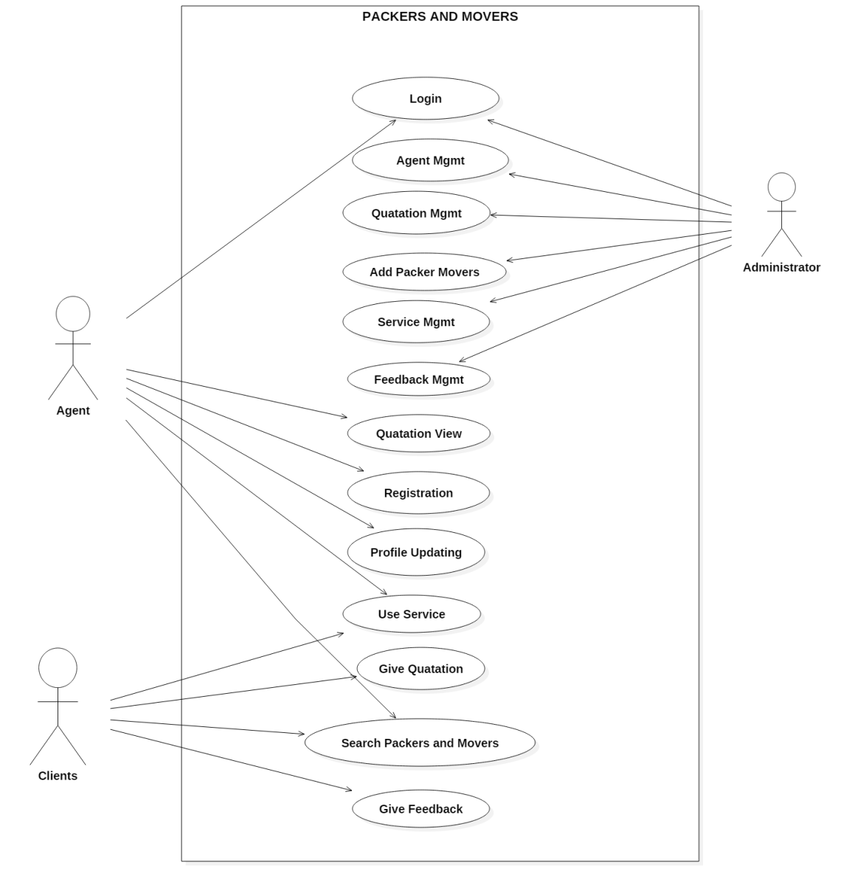

Client Use Case Diagram-

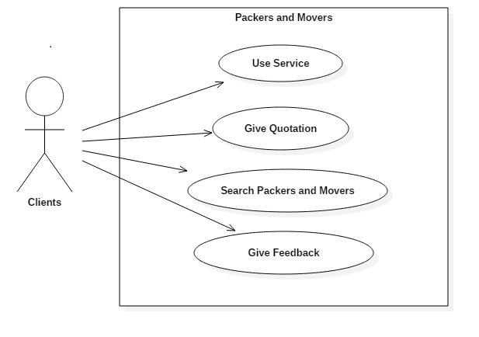

Administrator Use Case Diagram-

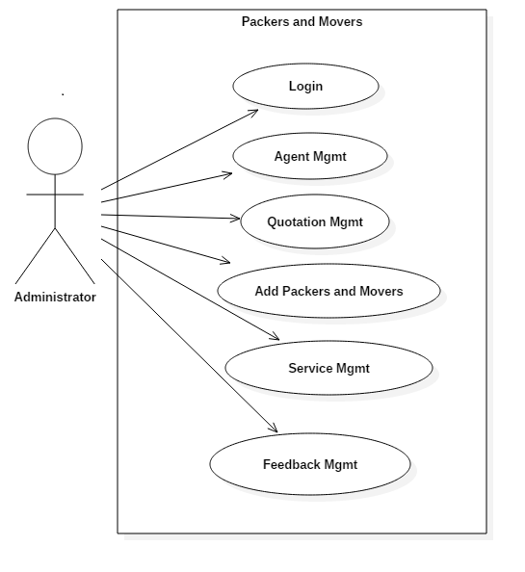

Agents Use Case Diagram-

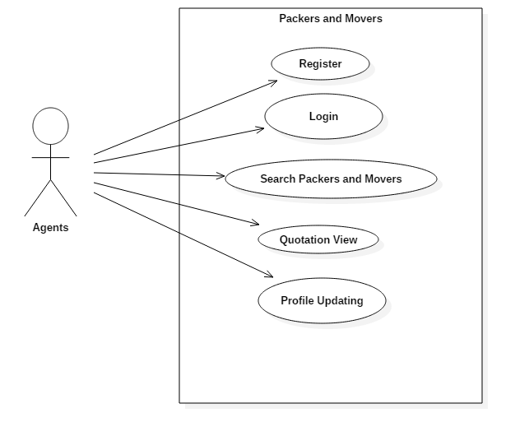

**3.2 Activity Diagram**

ActivityDiagramAdministrator**:-**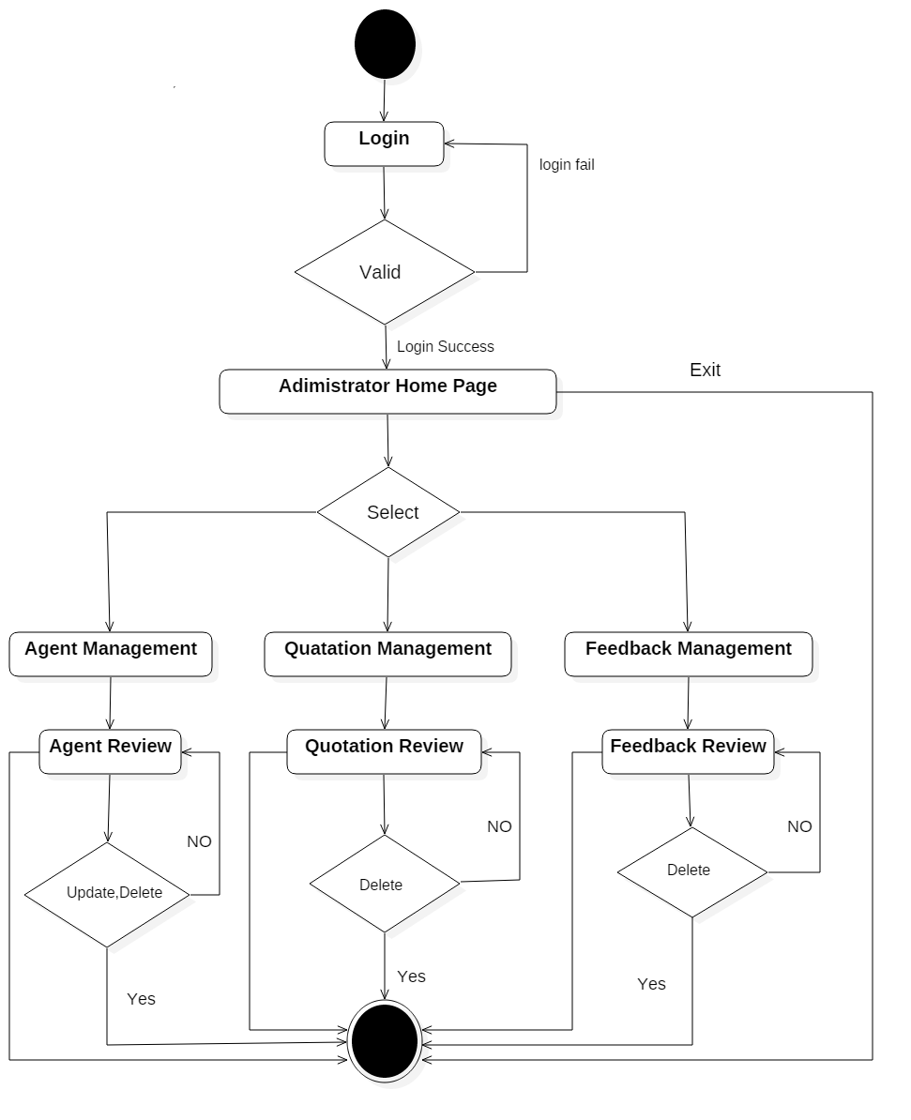

ActivityDiagramAgents**:-**

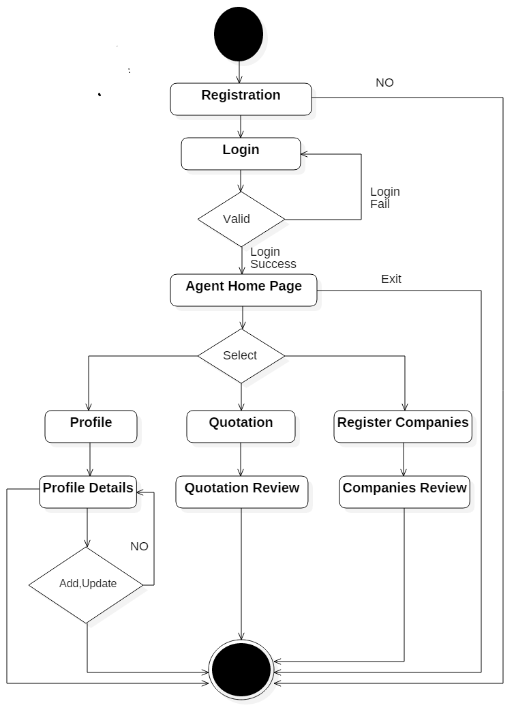

ActivityDiagramAgents**:-**

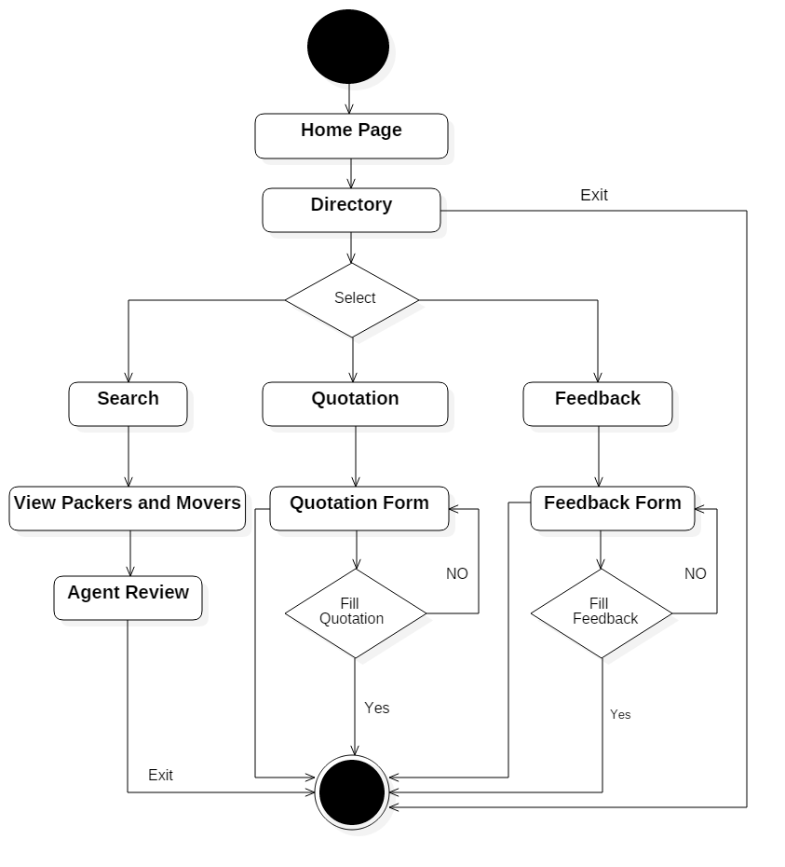

**3.3 Sequence Diagram**

Sequence Diagram Administrator:-

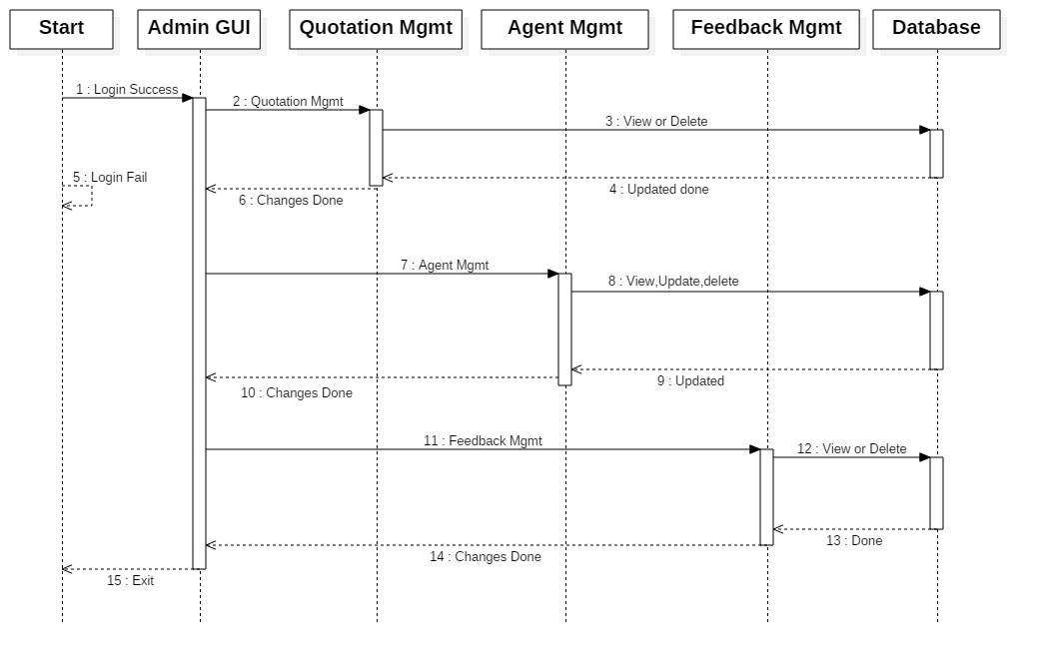

Sequence Diagram Agents:-

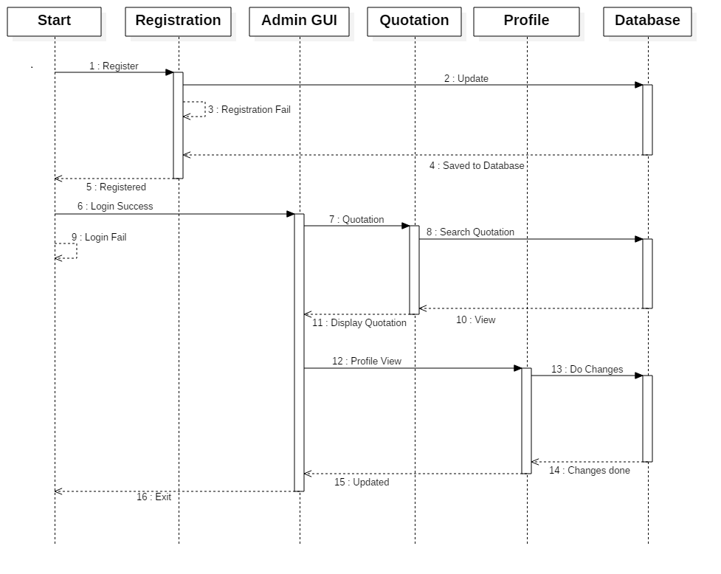

Sequence Diagram Clients:-

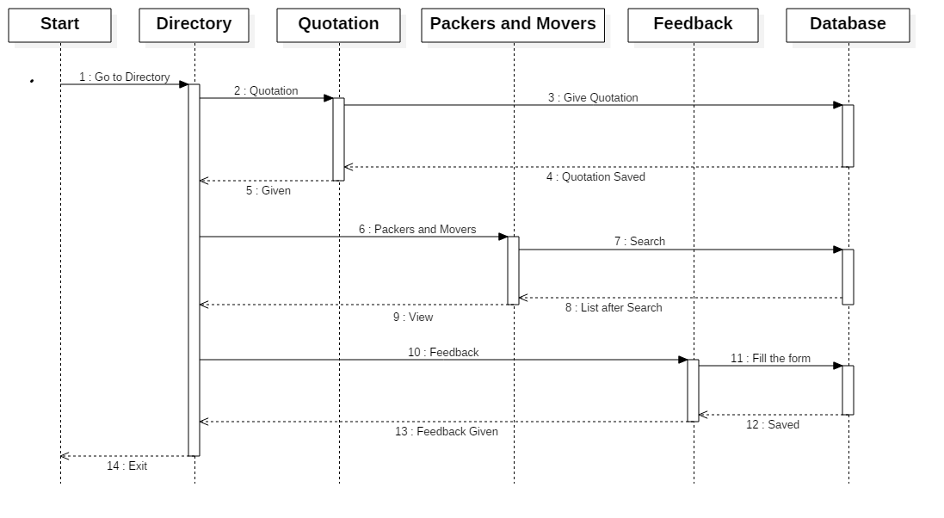

**3.4 Collaboration Diagram**

Collaboration diagram Administrator

1: Go to Home

12: Exit

**Administrator** 11: Redirect to Home 2: Go to Login

Admin Home Page

Registered Companies

Quotation Information

Agents

Quotation

Login

Home Page

3: Login Success 4: Login Fail

5: To View Quotation 6: To give Profile 7: To search Packers 10: Redirect

8: Redirect 9: Redirect

Feedback

6.1: Do Changes 6.2: Cancel

5.1: Search 5.2: View/Delete Quotations 6.3: Update 7.1: Search 7.2 view/ delete

Feedback Information

Collaboration diagram Agents-

1: Go to Home

Home Page

12.Exit

**Agents** 11:Redirect to Home 2: Go to Login

Login

3: Loin Success 4: Login Fail

Agent Home Page

6:To give

5:To view Quotation profile 7:To Search packers 9:Redirect

Profile

8:Redirect 9:Redirect

Search Packers and Movers

Quotation

Profile Information

5.1 Search 5.2 View Quotation 6.2 Cancel

Quotation Information

6.1: Do Change 6.3: Update 7.1: Search Redirect

Registrated Companies

Collaboration diagram Clients-

1: Go to Home

Home Page

10: Exit

**Client**  9: Redirect to Home 2: Go to Directory

Directory

3: To fill Quotation 4: To give Feedback 7: Redirect 8: redirect

Feedback

6: Redirect 5: To search Packers & Movers

Quotation Information

Quotation

Search Packers &Movers

3.1: Quotation

Placed 3.2: Cancel 4.2:Cancel 5.2 View

4.1: Feedback

Given 5.1: Search

Registered Companies

Feedback Information

**3.5 Class Diagram**

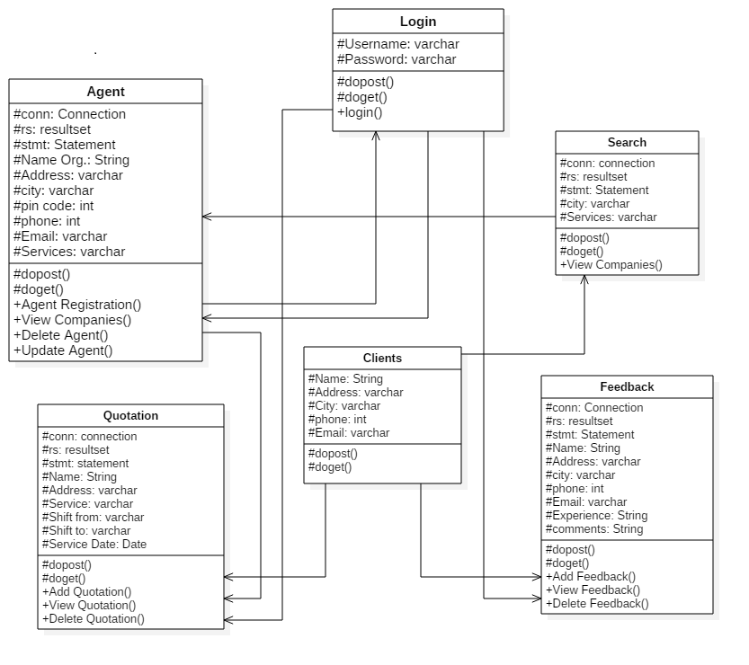

**3.6 Web site menu map diagram**

Packers and Movers

Clients

About us

Login

Service

Home

Administration Login

Agents Management

Quotation Management

Maintenance Management

Services

Quotation

Feedback

Feedback Management

Registration

Agent Login

Service Management

Quotation View

Profile Update

Vehicle Management

Driver Management

**3.7 File/ Database Design**

**Service**

Service_id

Service_type

**Feedback**

Feed_id

Name

Company

Address

City

Pincode

Email

Phone

Experience

comment

**Quotation**

Quo_id

Service_id

Name

Email

Mobile

Shift_from

Shift_to

Service_date

Contact_date

Reference

Details

**Agents**

Agnt_id

Name_org

Address

City

State

Pincode

Name

Phone

Email

User_id

Password

Mobile

Service_id

**Hard Disk**

**Packers and Movers**

**Login**

User_id

password

**Driver**

Driver_id

Name

Address

Phone

City

State

Idproof

salary

**Maintenance**

Main_id

Vehicle_id

Main_date

Tire

Body

Transmission

engine

**Vehicle**

Vehicle_id

Name

Vehicle_comp

Price

Capacity

Numeber

Purchase_Date

**Hard Disk**

**Packers and Movers**

**3.8 Data Dictionary**

**Login Data Model:-**

|  |  |  |  |  |
| --- | --- | --- | --- | --- |
| **Column Name** | **Data Type and Size** | **Default** | **Constraints** | **Description** |
| User_id | Varchar(5) | Not Null | - | login_Id for agent login or Admin Login |
| Password | Varchar(10) | Not Null | - | Key for successful login |

**Agent Data Model:-**

|  |  |  |  |  |
| --- | --- | --- | --- | --- |
| **Column Name** | **Data Type and Size** | **Default** | **Constraints** | **Description** |
| Agnt_id | Integer(5) | Not Null | Primary Constraints | Agent ID |
| Name_org | Varchar(20) | Not Null | Unique Constraints | Organization or Company Name |
| Address | Varchar(50) | Not Null | - | Address of company |
| City | Varchar(10) | Not Null | - | City of company |
| State | Varchar(15) | Not Null | - | State of company |
| Pin code | Integer(8) | Not Null | - | Pin code of the company |
| Name | Varchar(10) | Not Null | - | Name of the person to contact |
| Phone | Integer(12) | Not Null | - | Phone number for Communication |
| Email_Id | Varchar(15) | Not Null | - | Valid Email Id |
| User_id | Varchar(10) | Not Null | - | login_Id for agent login |
| Password | Varchar(10) | Not Null | - | Key for successful login |
| Mobile_no | Integer(12) | Not Null | - | Valid mobile no. for communication |
| Service_id | Integer(5) | Not Null | Foreign Constraints | Type Services that the company |

**Quotation Data Model:-**

|  |  |  |  |  |
| --- | --- | --- | --- | --- |
| **Column Name** | **Data Type and Size** | **Default** | **Constraints** | **Description** |
| Qua_Id | Integer(5) | Not Null | Primary Constraints | Quotation Id |
| Service_id | Integer(5) | Not Null | Foreign Constraints | Type Services that the company |
| Name | Varchar(20) | Not Null | - | Name of the person to contact |
| Email_Id | Varchar(15) | Not Null | - | Valid Email-Id |
| Mobile_No | Integer(12) | Not Null | - | Valid mobile number for communication |
| Shift_from | Varchar(10) | Not Null | - | City from where to shift |
| Shift_to | Varchar(10) | Not Null | - | City to shift there |
| Service_Date | Date | Not Null | - | The Date on which to shift |
| Contact_time | Date | Not Null | - | The time when to meet is to be done |
| References | Varchar(20) | Not Null | - | References of the persons |
| Details | Varchar(100) | Not Null | - | Other Details that are required |

**Feedback Data Model:-**

|  |  |  |  |  |
| --- | --- | --- | --- | --- |
| **Column Name** | **Data Type and Size** | **Default** | **Constraints** | **Description** |
| Feed_Id | Integer(5) | Not Null | Primary Constraints | Feedback Id |
| Name | Varchar(20) | Not Null | - | Name of the Person to Contact |
| Company | Varchar(10) | Not Null | - | Name of the Organization or Company |
| Address | Varchar(50) | Not Null | - | Address of the Clients |
| City | Varchar(10) | Not Null | - | City of the Clients |
| Pin_code | Integer(8) | Not Null | - | Pin Code Number of the City |
| Email_ID | Varchar(15) | Not Null | - | Valid Email |
| Phone | Integer(12) | Not Null | - | Valid Phone No. for communication |
| Experience | Varchar(20) | Not Null | - | Experience details if there |
| Comments | Varchar(50) | Not Null | - | Comments if he wishes |

**Service Type Model:-**

|  |  |  |  |  |
| --- | --- | --- | --- | --- |
| **Column Name** | **Data Type and Size** | **Default** | **Constraints** | **Description** |
| Service_id | Integer(5) | Not Null | Primary Constraints | Type Services Id that the company |
| Service_Type | Varchar(15) | Not Null | - | Type Services that the company |

**Vehicle Data Model:-**

|  |  |  |  |  |
| --- | --- | --- | --- | --- |
| **Column Name** | **Data Type and Size** | **Default** | **Constraints** | **Description** |
| Vehicle_id | Integer(5) | Not Null | Primary Constraints | Vehicle Id |
| Name | Varchar(20) | Not Null | - | Name of the vehicle |
| Vehicle_comp | Varchar(20) | Not Null | - | Name of company vehicle |
| Price | Integer(10) | Not Null | - | Price of the vehicle |
| Capacity | Varchar(10) | Not Null | - | Capacity of the vehicle |
| Number | Varchar(10) | Not Null | - | Number plate of the vehicle |
| Purchase_Date | Date | Not Null | - | Purchase date of the vehicle |

**Vehicle Maintenance Data Model:-**

|  |  |  |  |  |
| --- | --- | --- | --- | --- |
| **Column Name** | **Data Type and Size** | **Default** | **Constraints** | **Description** |
| Main_id | Integer(5) | Not Null | Primary Constraints | Maintenance Id |
| Vehicle_id | Integer(5) | Not Null | Foreign Constraints | Vehicle Id |
| Main_Date | Date | Not Null | - | Date of Maintenance |
| Tire_price | Integer(10) | Not Null | - | Price of tires |
| Body_price | Integer(10) | Not Null | - | Price of body |
| Transmission_price | Integer(10) | Not Null | - | Price of Transmission |
| Engine_price | Integer(10) | Not Null | - | Price of Engine |

**Drivers Data Model:-**

|  |  |  |  |  |
| --- | --- | --- | --- | --- |
| **Column Name** | **Data Type and Size** | **Default** | **Constraints** | **Description** |
| Driver_id | Integer(5) | Not Null | Primary Constraints | Driver Id |
| Name | Varchar(20) | Not Null | - | Name Of Driver |
| Address | Varchar(50) | Not Null | - | Address of Driver |
| Phone | Integer(12) | Not Null | - | Phone No. of Driver |
| City | Varchar(10) | Not Null | - | City of Driver |
| State | Varchar(15) | Not Null | - | State of Driver |
| Id_proof | Varchar(10) | Not Null | - | Identity of Driver |
| Salary | Integer(10) | Not Null | - | Salary of Drivers |

**CHAPTER 4 : USER MANUAL**

* 1. **User Manual**

This is web based application developed for packers and movers. This application allows the handle and mange the packing, transporting, and all details of the packers and movers operation on website. This application is easy, simple and reliable to use and no need to install it.

To run this web applications you have write url in your browser

http://localhost:8080/Packers/index.html

Home page of Packers and Movers are Displayed, at right side u will see login if click on that there are available admin and agent login section.

**Create Agent Registration:**

1. Click on Agent Login Section.
2. Click on Register
3. Import The records and submit
4. Login Agent by use user_id and password.

**Create Quotation:**

1. Click on service
2. Click quotation button
3. Fill up the records and Submit

**Create Feedback:**

1. Click on service
2. Click on Feedback button
3. Fill up records and Submit

**If you are Admin then following operation is performed:**

Administrator can Manage all system of packers and Movers.

The admin can be manage Quotation, Admin have rights to to delete the quotations. Admin have mange the agent data, feedbacks, services, vehicle, maintenance and drivers.

**If you are Agent then following operation is performed:**

Agent can See the Customer Quotations He can’t delete the quotation. Agent can update his profile.

**If you are Client then following operation is performed:**

Client can be give the quotation and feedback to the organization, also client can give a detail description.

* 1. **Operations Manual / Menu Explanation**

This is web based application developed for packers and movers. This application allows the handle and mange the packing, transporting, and all details of the packers and movers operation on website. This application is easy, simple and reliable to use and no need to install it.

To run this web applications you have write url in your browser

http://localhost:8080/Packers/index.html

Home page of Packers and Movers are Displayed, at right side u will see login if click on that there are available admin and agent login section.

**Create Agent Registration:**

1. Click on Agent Login Section.
2. Click on Register
3. Import The records and submit
4. Login Agent by use user_id and password.

**Create Quotation:**

1. Click on service
2. Click quotation button
3. Fill up the records and Submit

**Create Feedback:**

1. Click on service
2. Click on Feedback button
3. Fill up records and Submit

**If you are Admin then following operation is performed:**

Administrator can Manage all system of packers and Movers.

The admin can be manage Quotation, Admin have rights to to delete the quotations. Admin have mange the agent data, feedbacks, services, vehicle, maintenance and drivers.

**If you are Agent then following operation is performed:**

Agent can See the Customer Quotations He can’t delete the quotation. Agent can update his profile.

**If you are Client then following operation is performed:**

Client can be give the quotation and feedback to the organization, also client can give a detail description.

**4.3 Forms and Reports**

**Home Page-**

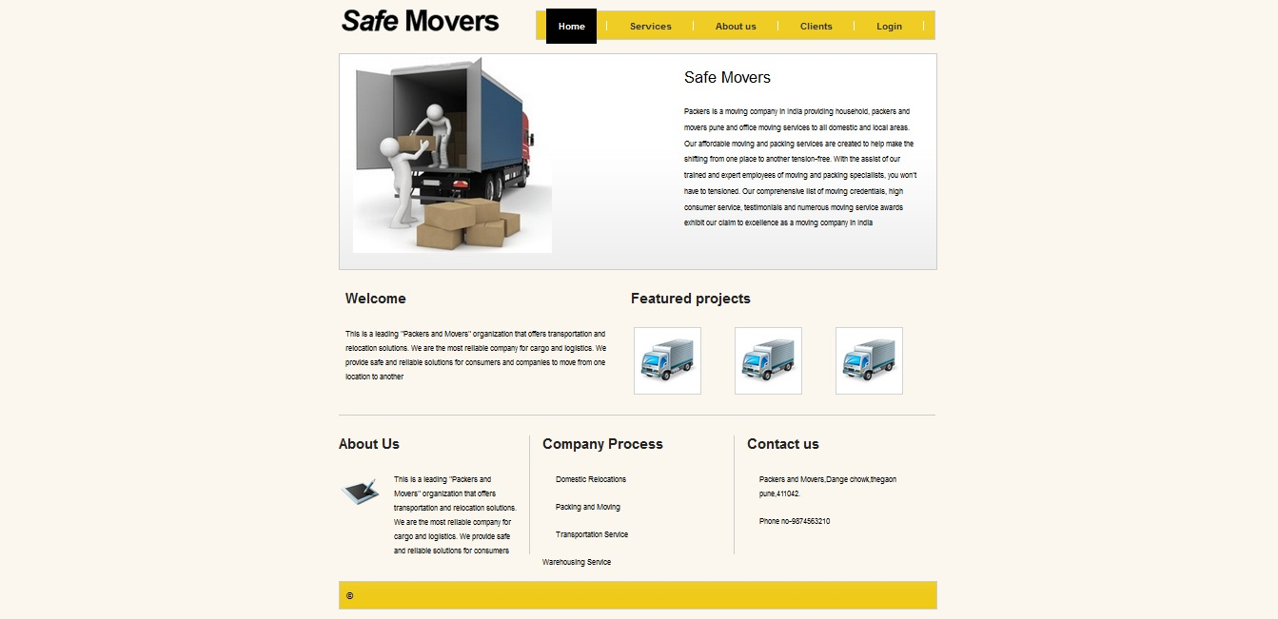

**Service page-**

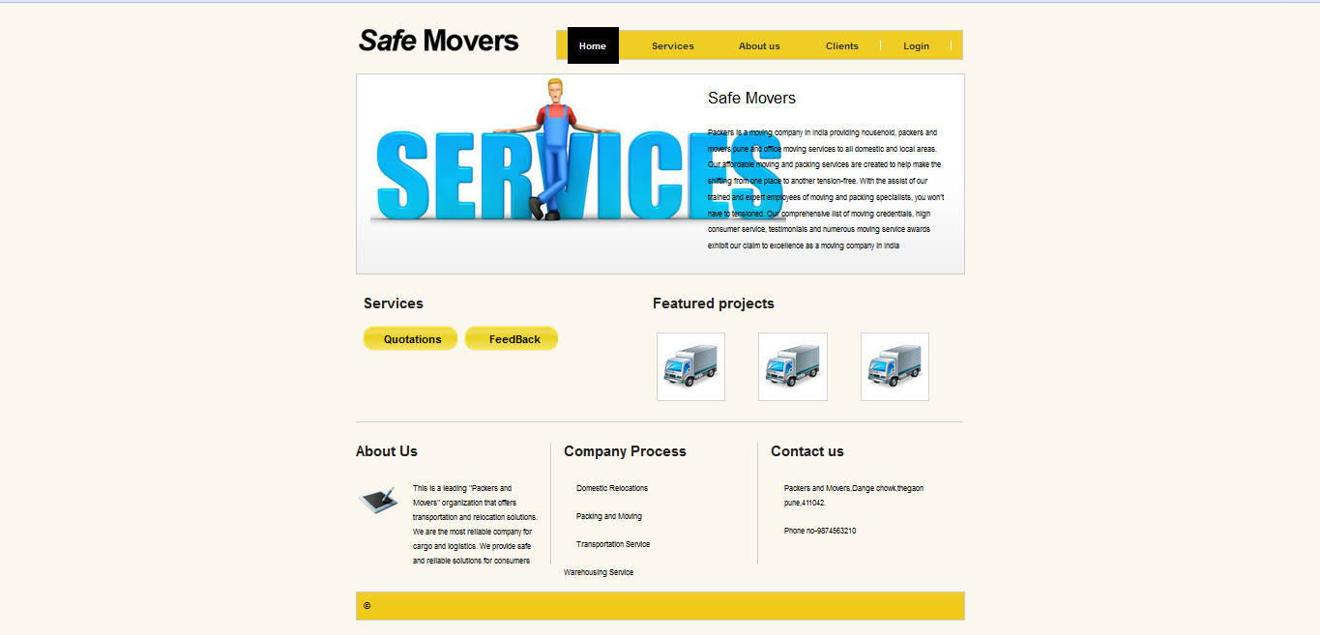

**Quotation page-**

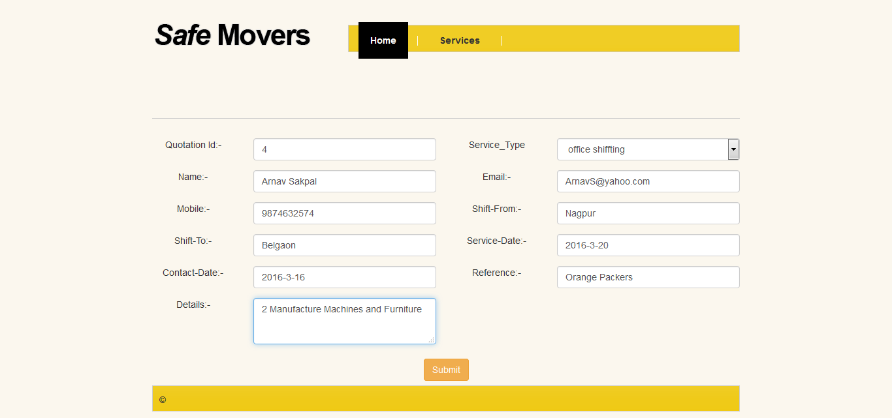

**Quotation Reports-**

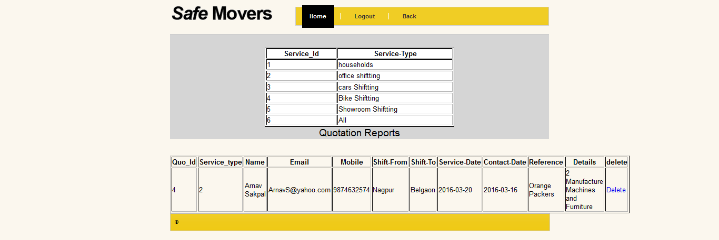

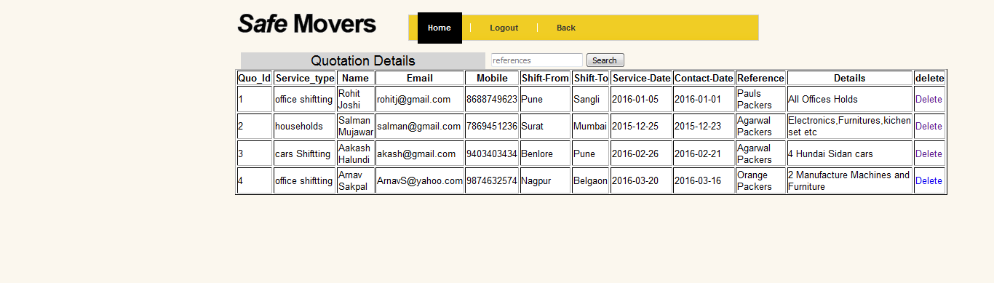

**Feedback page-**

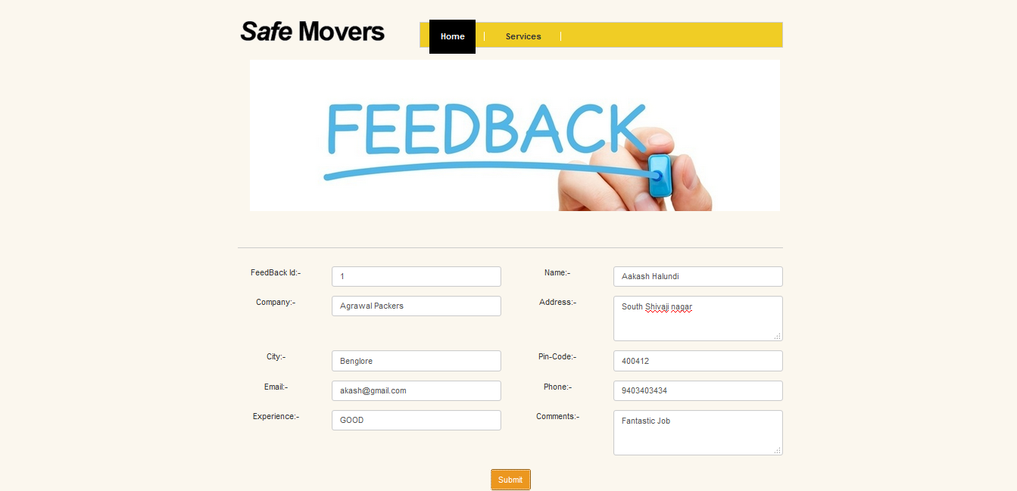

**Feedback Reports-**

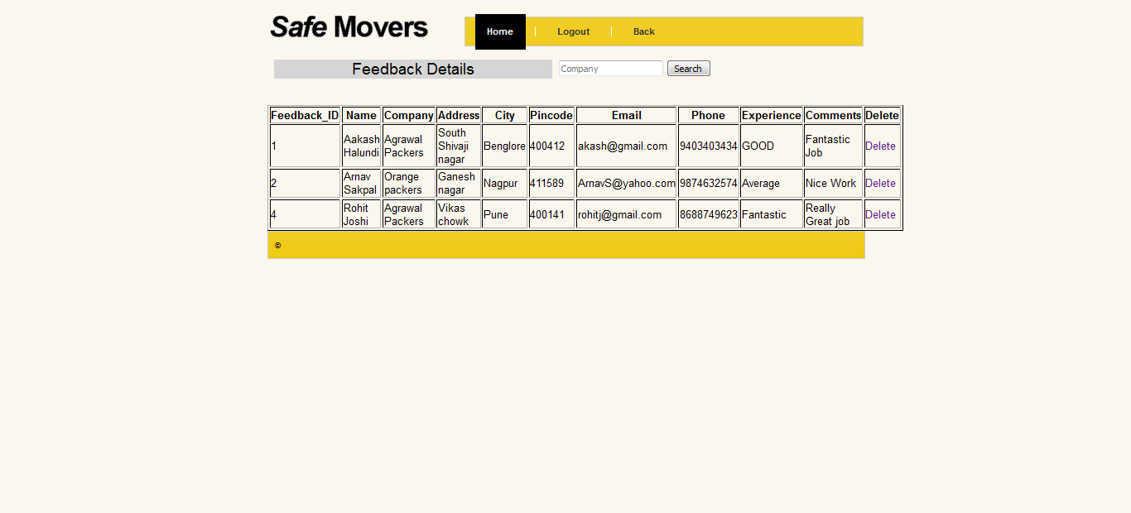

**Agent Registration-**

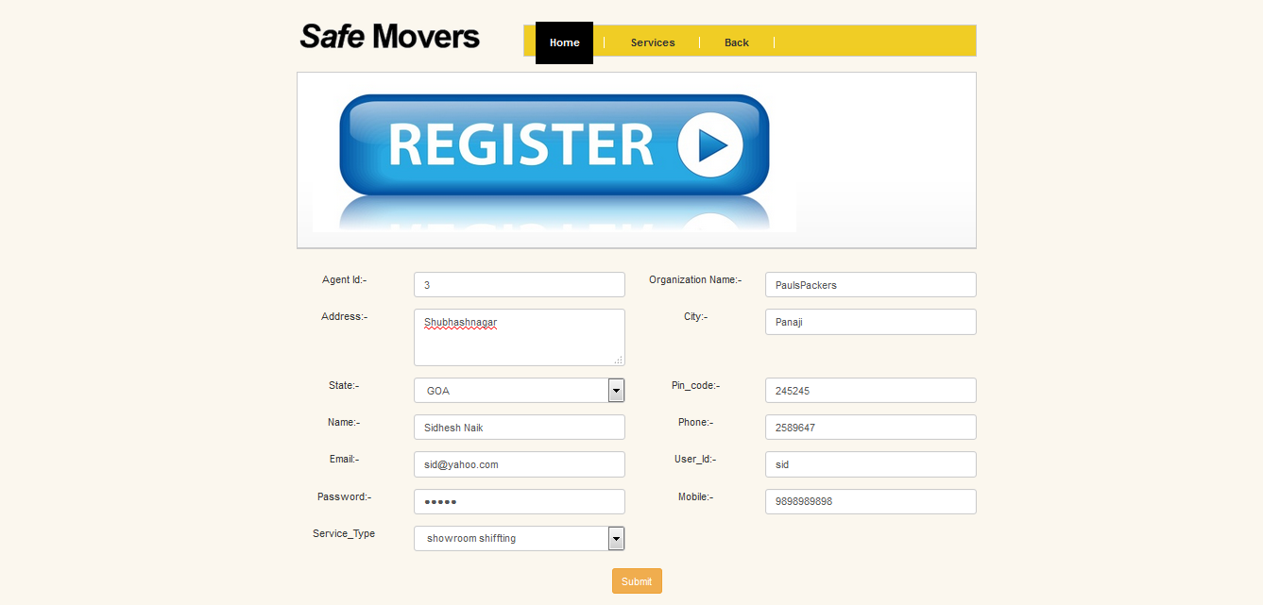

**Agents Reports-**

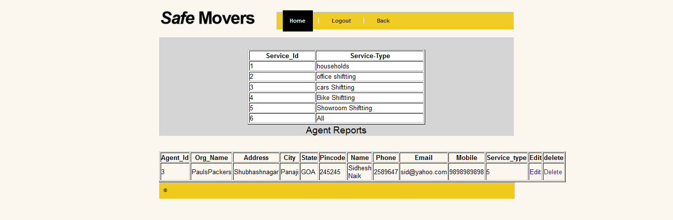

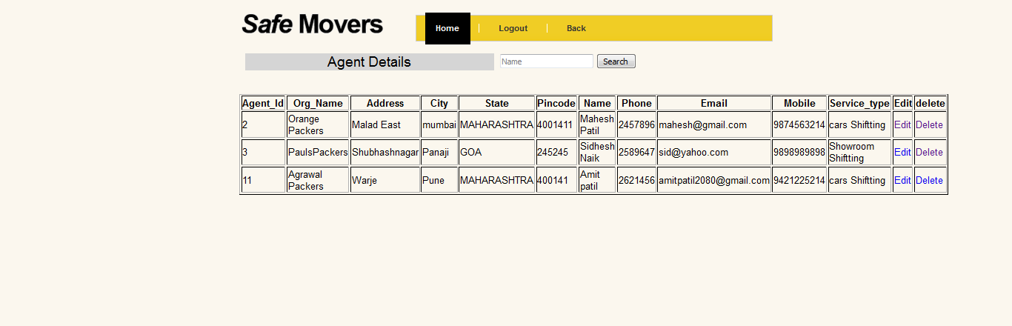

**Adminstration Login-**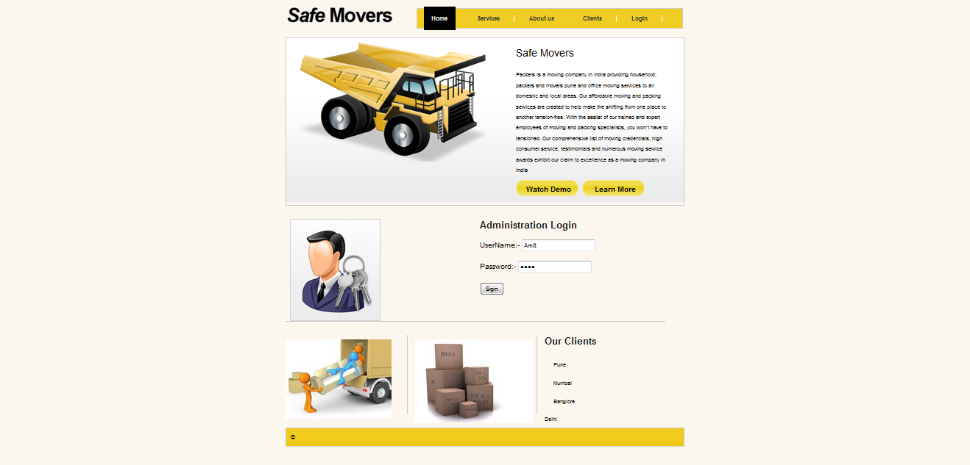

**Agent Login-**

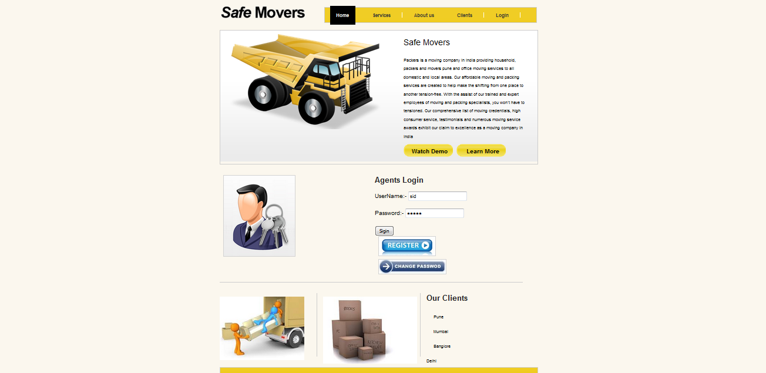

**Administration Management-**

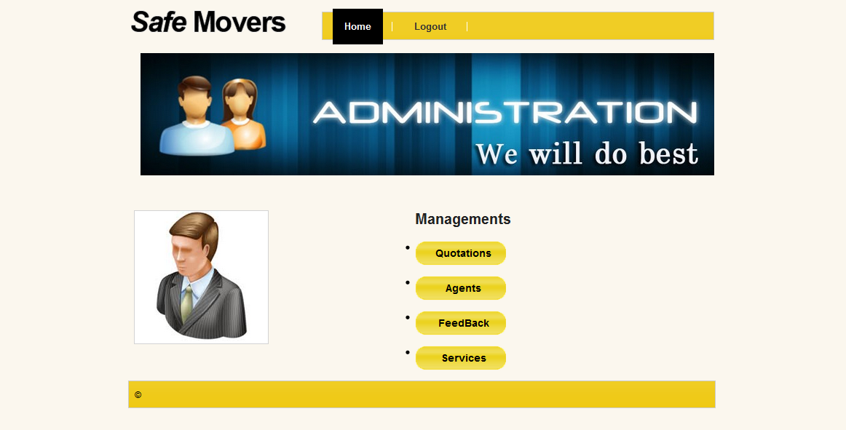

**Quotations Management-**



**Agents Management-**



**Feedback Management-**



**Service Management-**

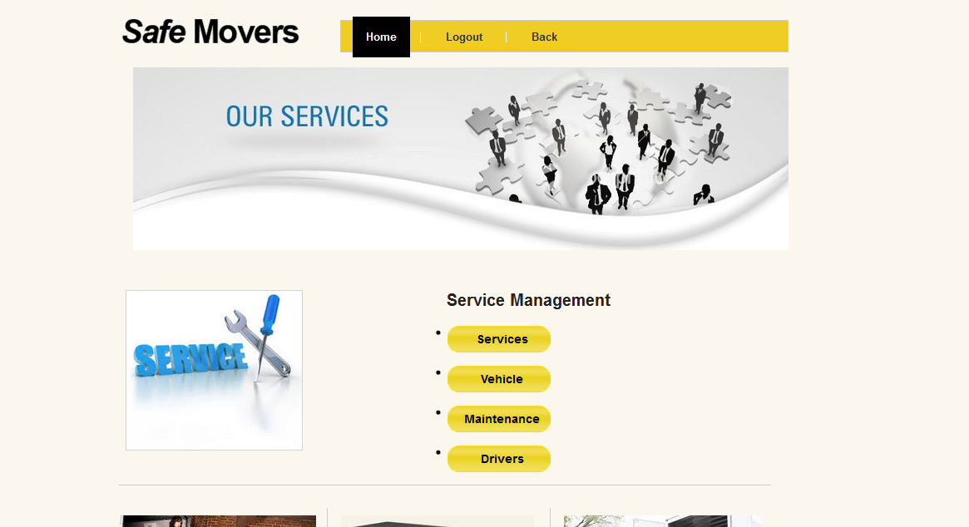

**Service-**

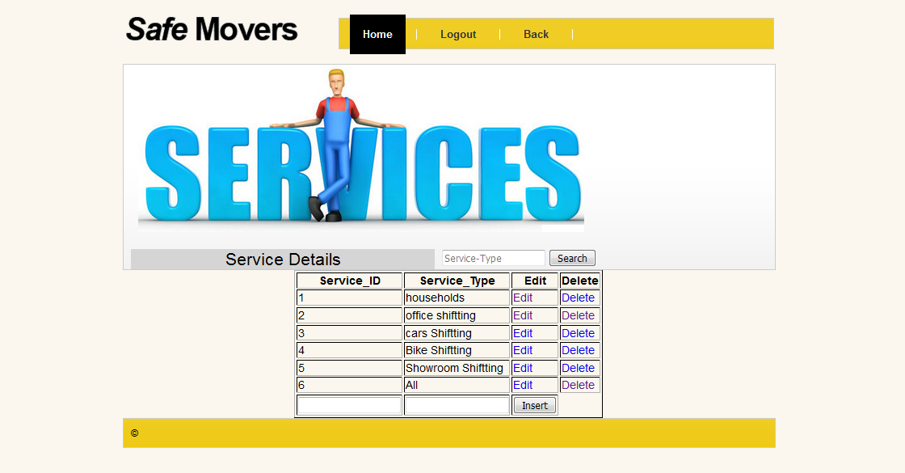

**Vehicle Management-**

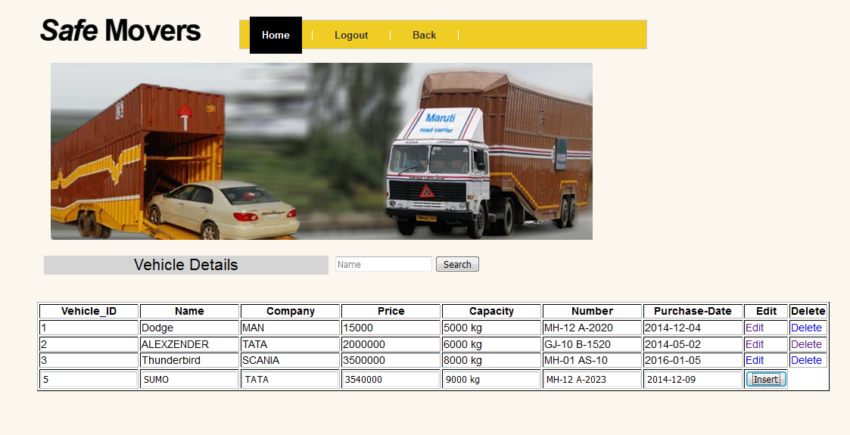

**Vehicle Reports-**

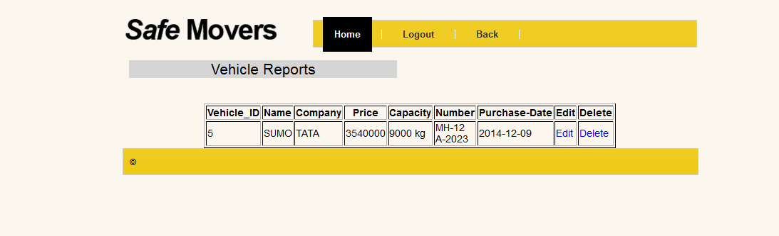

**Maintenance page-**

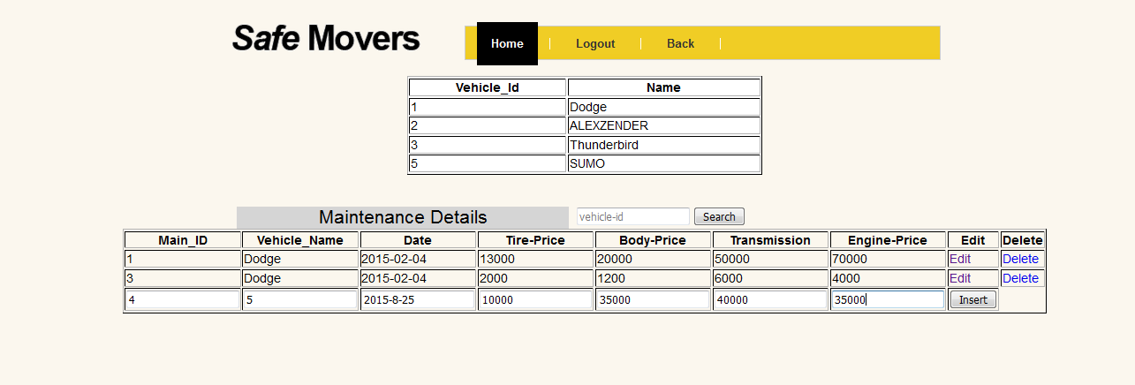

**Maintenance Reports-**

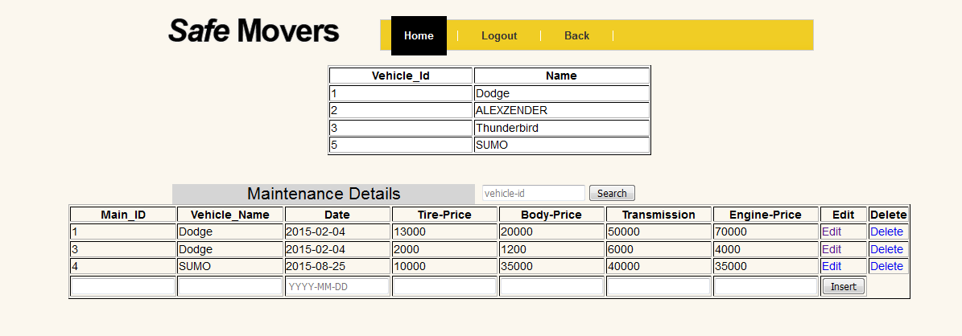

**Driver pages-**

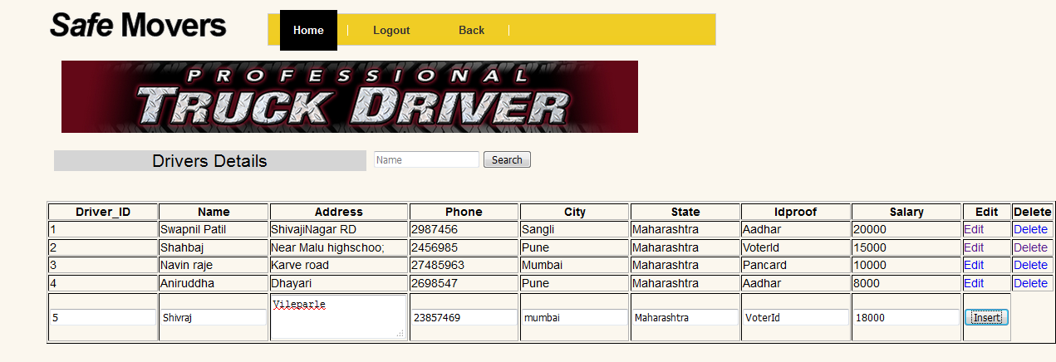

**Drivers Reports-**

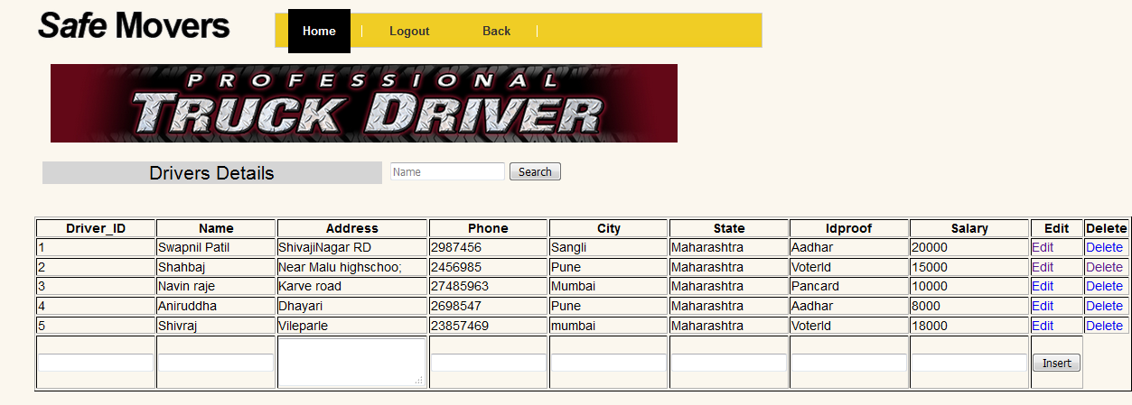

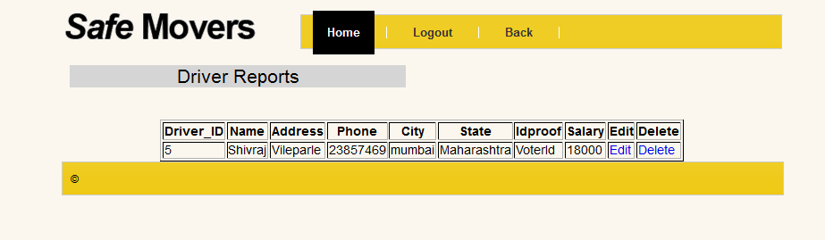

**Agent Management-**

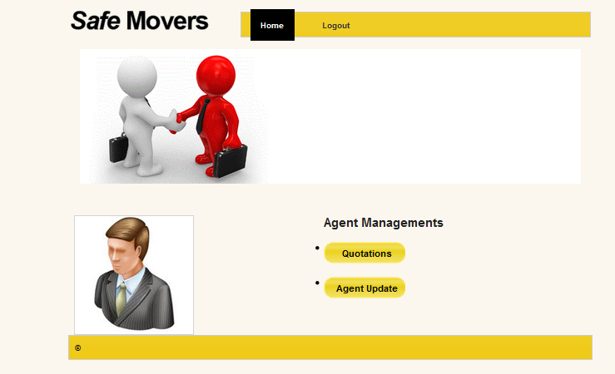

**Quotation View-**

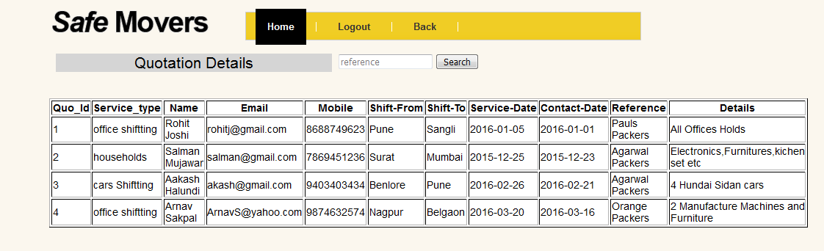

**Agent Profile Update-**

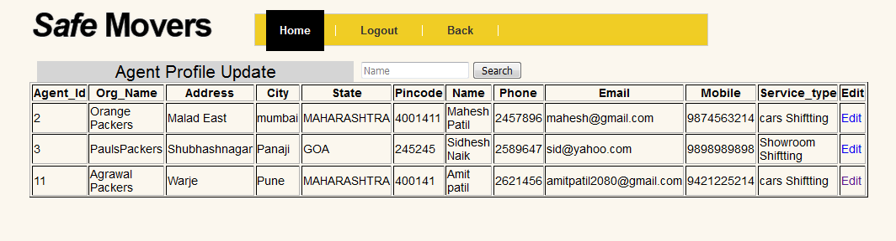

**Validations:-**

**Blank Fields -**

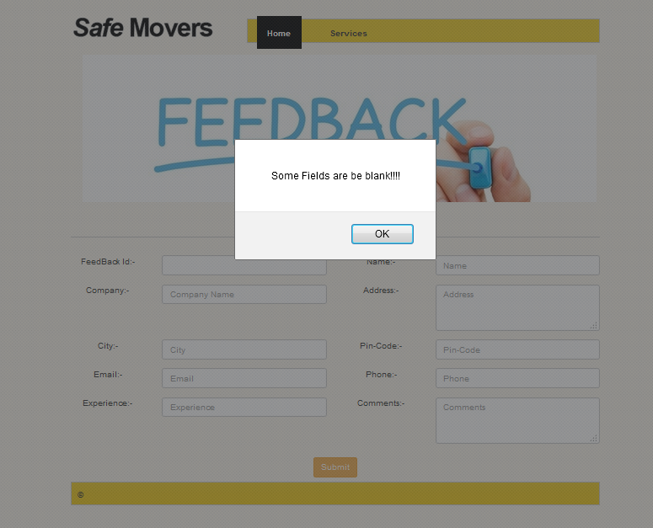

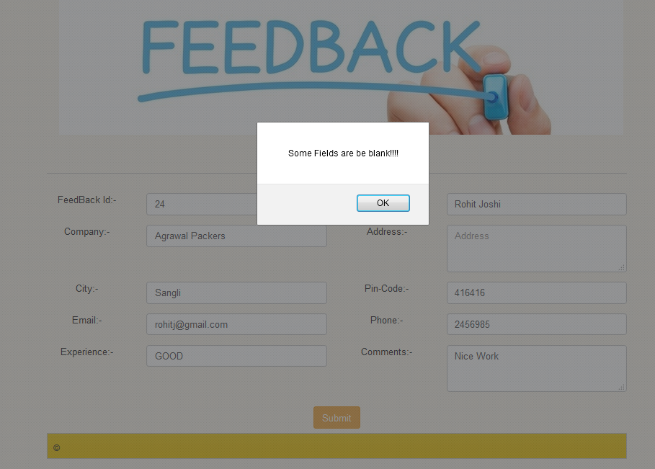

**Number Validation-**

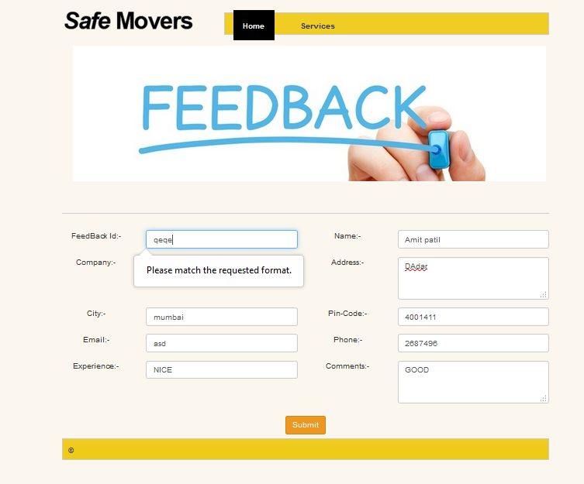

**Character Validation-**

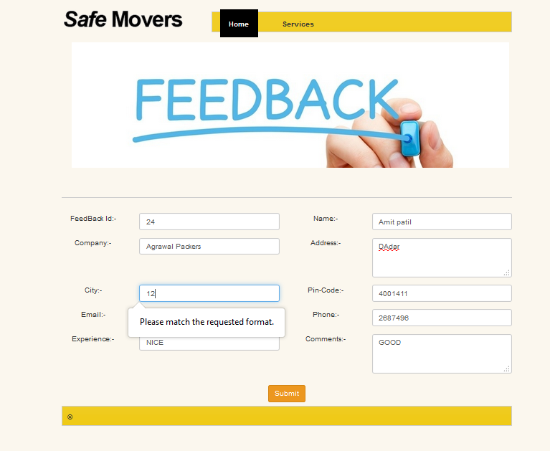

**Email Validation-**

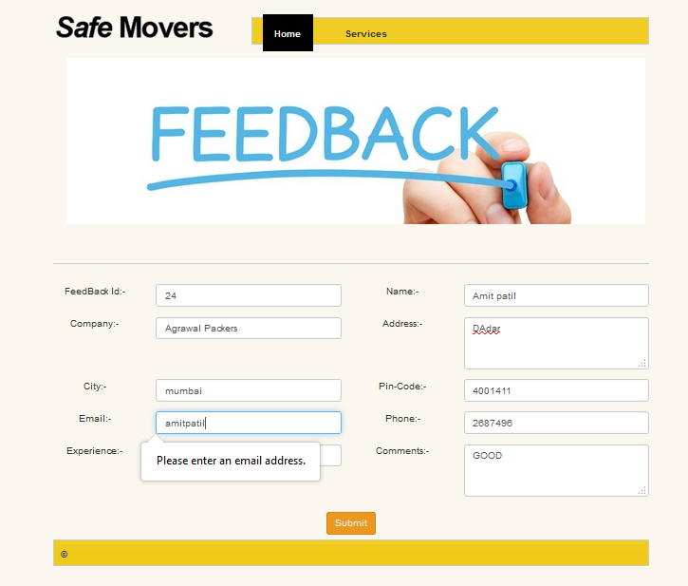

**4.4 Test Procedures and cases**

**WHITE BOX TESTING**

Using the white-box testing techniques, a software engineer can design test case that

* Exercise independent paths within a module or unit
* Exercise logical decisions on both their true and false side
* Execute loops at their boundaries and within their operational bounds
* Exercise internal data structures to ensure their validity

**UNIT TESTING**

Code is written by people, and we make mistakes. Bugs to prevent us from shipping bugs to our users, we test our software to verify that it works as it should. Java developers have learned that not all testing is created equal. In addition to traditional functional testing, many shops are adopting developer testing techniques such as unit testing. These leading craftsmen create specific, automated tests to verify the accuracy and function of code while it's being written - or even before it's written - because they want to catch bugs early. Better still, new tools and processes make unit testing even more attractive to Java developers

Unit Testing in Java is written to show how to write good tests — tests that are concise and to the point, expressive, useful, and maintainable. Inspired by Roy Osherove's bestselling The Art of Unit Testing, this focuses on tools and practices specific to the Java world. It introduces you to emerging techniques like behavior-driven development and specification by example, and shows you how to add robust practices into your toolkit.

If you're already doing unit testing, you'll learn the current state of the art, along with the insights and experience of expert author Lassa Koskela. If these practices are new to you, you’ll get started on the right foot as you learn to write tests that build on more than a decade of community experience

**INTEGRATION TESTING**

Once unit tested components are delivered we then integrate them together. These “integrated” components are tested to weed out errors and bugs caused due to the integration. This is a very important step in the Software Development Life Cycle.

It is possible that different programmers developed different components. A lot of bugs emerge during the integration step. In most cases a dedicated testing team focuses on Integration Testing

**Prerequisites for Integration Testing:**

Before we begin Integration Testing it is important that all the components have been successfully unit tested

.

**Integration Testing Steps:**

Integration Testing typically involves the following Steps

* Step 1: Create a Test Plan
* Step 2: Create Test Cases and Test Data
* Step 3: If applicable create scripts to run test cases
* Step 4: Once the components have been integrated execute the test cases
* Step 5: Fix the bugs if any and re test the code
* Step 6: Repeat the test cycle until the components have been successfully integrated

**SYSTEM TESTING**

The prerequisites for System Testing are:

* All the components should have been successfully Unit Tested
* All the components should have been successfully integrated and Integration
* Testing should be completed
* An Environment closely resembling the production environment should be created.
* When necessary, several iterations of System Testing are done in multiple environments.

Steps needed to do System Testing:

The following steps are important to perform System Testing:

* Step 1: Create a System Test Plan
* Step 2: Create Test Cases
* Step 3: Carefully Build Data used as Input for System Testing
* Step 3: If applicable create scripts to
* Build environment and
* to automate Execution of test cases
* Step 4: Execute the test cases
* Step 5: Fix the bugs if any and re test the code
* Step 6: Repeat the test cycle as necessary

**BLACK BOX TESTING**

Black box testing takes an external perspective of the test object to derive test cases. These tests can be functional or non-functional, though usually functional. The test designer selects valid and invalid input and determines the correct output. There is no knowledge of the test object’s internal structure. This method of test design is applicable to all levels of software testing: unit, integration, functional testing, system and acceptance. The higher the level, and hence the bigger and more complex the box, the more one is forced to use black box testing to simplify. While this method can uncover unimplemented parts of the specification, one cannot be sure that all existent paths are tested.

**4.4 Implementations**

1.Registration Modules

To access our services an Agent has first have to register to the system by providing all the required information.

**Input of the Modules:-**

1. Agent_id
2. Organization_Name
3. Address
4. City
5. State
6. Pin code
7. Name
8. Phone
9. Email
10. User_id
11. Password
12. Mobile
13. Service_type

**Output of the Module-**

Agent Register Confirm or failure

2. Agent Login Modules-

To go to the required home page for various operation Agent login is important

**Input of the Modules:-**

1. User_id
2. Password

**Output of the Module-**

Agent Login Confirmed or failure

3.Admin Login Modules-

To go to the required home page for various operation Admin login is important

**Input of the Modules:-**

1. User_id
2. Password

**Output of the Module-**

Admin Login Confirmed or failure

3.Service Modules-

To go to the admin management then service management then import services

**Input of the Modules:-**

1. Service_id
2. Service_type

**Output of the Module-**

Service Confirmed or failure

3.Vehicle Modules-

To go to the admin management then vehicle management then import information’s

**Input of the Modules:-**

1. Vehicle_id
2. Name
3. Company
4. Price
5. Capacity
6. Number
7. Purchase_date

**Output of the Module-**

Vehicle Details Confirmed or failure

3.Maintenance Modules-

To go to the admin management then maintenance management then import information’s

**Input of the Modules:-**

1. Main_id
2. Vehicle_name
3. Date
4. Tire
5. Body
6. Transmission
7. Engine

**Output of the Module-**

Maintenance Data Confirmed or failure

4.Drivers Modules-

To go to the admin management then drivers management then import information’s

**Input of the Modules:-**

1. Driver_id
2. name
3. Address
4. phone
5. city
6. state
7. Idproof
8. Salary

**Output of the Module-**

Driver Data Confirmed or failure

4.Quotation Modules-

To go to the service page then quotation then import quotation.

**Input of the Modules:-**

1. Quotation_id
2. Service_type
3. Name
4. Email
5. Mobile
6. Shift_from
7. Shift_to
8. Service_date
9. Contact_date
10. Reference
11. Details

**Output of the Module-**

Quotation Confirmed or failure

5.Feedback Modules-

To go to the service page then Feedback then import feedback.

**Input of the Modules:-**

1. Feedback_id
2. Name
3. Company
4. Address
5. City
6. Pin code
7. Email
8. Phone
9. Experience
10. comments

**Output of the Module-**

Feedback Confirmed or failure

**CHAPTER 5: DRAWBACK AND LIMITATION**

* A System has limit users and agents
* GUI is only in English
* Application and forma is not responsible for entries provided may be wrong
* There is no Payment modes is Provided for the Portal.

**CHAPTER 6: PROPOSED ENHANCEMENT**

1. The Clients can be only give the Quotation and feedback to the organization.
2. The Agent Can be view the Quotation and update his profile.
3. The Admin can manage overall management, admin can be delete and modify the date of quotations, feedbacks, services and agents.
4. Admin and agent generate the reports.
5. New agent must register first and then login.

**CHAPTER7: CONCLUSION**

According to requirement gathered and the technologies used to realize those requirements are best utilized to achieve that functionality. The Packers and Movers Web Portal gives a platform through which clients and different packing and moving companies can communicate and use the services provided by this portal.

**FUTURE SCOPE OF THE PROJECT**

This application can be further used in developing many new applications such as Property broker application. We can listed excellent packers movers and property brokers of India. We can also list packers movers and other service providers of India according to the city such as Agra, Ahmadabad, Allahabad, Ambala, Amritsar, Bangalore, Bhatinda, Bhopal, Bhubaneswar, Bikaner, Chandigarh, Chennai, Cochin, Coimbatore, Dehradun, Delhi, Faridabad, Ghaziabad, Goa, Gorgon, Gandhi Dham, Guwahati, Gwalior, Hissar, Hyderabad, Indore, Jaipur, Jamnagar, Kanpur, Kolkata, Kurukshetra, Lucknow, Ludhiana, Madurai, Mangalore, Mumbai, Nagpur, Noida, Panipat, Pathankot, Patiala, with their head offices or branches which are considered reliable, trustworthy and efficient in providing packing moving and other services.

**CHAPTER 8: BIBLIOGRAPHY**

**Book References**

* "Programming Language Popularity", 2009, Retrieved 2009-01-16
* "TIOBE Programming Community Index", 2009, Retrieved 2009-05-06.
* Gosling, James; and McGilton, Henry (May 1996). "The Java Language Environment
* Dr. Alan Kay on the Meaning of "Object-Oriented Programming"", 2003, Retrieved 11 February 2010

**Web References**

* <http://www.w3schools.com>
* <http://www.netbeans.org>
* <http://www.packersandmover.com>
* <http://www.agrawalmovers.com>
* <http://www.java.com>

**CHAPTER 9: ANNEXURE**

**ANNEXURE 1 : INPUT FORMS WITH DATA**

**Quotation Page**



**Feedback page**



**Agent Registration-**



**Services**



**Vehicle Page-**



**Maintenance Page-**



**Driver Page**



**ANNEXURE 2 : OUTPUT REPORTS WITH DATA**

Quotation Reports-





**Agent Reports-**





**Feedback Reports-**



**Service Reports-**

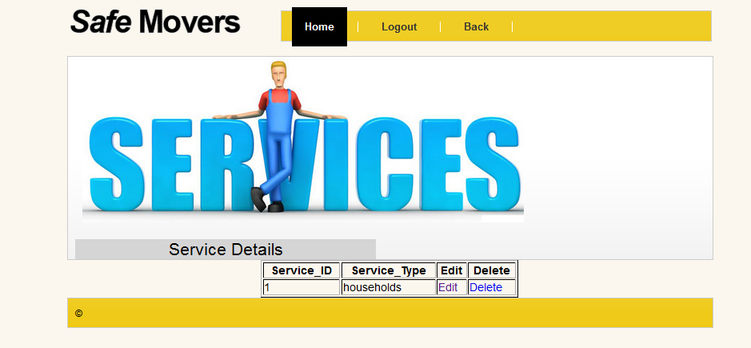

**Vehicle Reports-**



**Driver Reports-**



**Maintenance Reports-**



**ANNEXURE 3 : SAMPLE CODE**

**Agent Registration.jsp**

<%@page contentType="text/html" pageEncoding="UTF-8"%>

<!DOCTYPE html PUBLIC "-//W3C//DTD XHTML 1.1//EN" "http://www.w3.org/TR/xhtml11/DTD/xhtml11.dtd">

<html xmlns="http://www.w3.org/1999/xhtml">

<html>

<head>

<meta http-equiv="Content-Type" content="text/html; charset=UTF-8">

<title>Safe Movers</title>

<link href="css/bootstrap.min.css" rel="stylesheet" type="text/css">

<link href="styles/style.css" rel="stylesheet" type="text/css" />

<script type="text/javascript" src="scripts/vwd_curvycorners.js"></script>

<script type="text/javascript" src="scripts/capply.js"></script>

<!--[if lt IE 7]>

<style type="text/css">

.home .row{

padding-bottom:0;

}

.px_fix{

left:1px;

bottom:-3px;

}

</style>

<![endif]-->

<script>

function validate(){

var agentid=document.agntreg.agentid.value;

var nameorg=document.agntreg.nameorg.value;

var address=document.agntreg.address.value;

var city=document.agntreg.city.value;

var pincode=document.agntreg.pincode.value;

var name=document.agntreg.name.value;

var phone=document.agntreg.phone.value;

var x=document.agntreg.email.value;

var atposition=x.indexOf("@");

var dotposition=x.lastIndexOf(".");

var user=document.agntreg.user.value;

var pass=document.agntreg.pass.value;

var mobile=document.agntreg.mobile.value;

if((agentid==null || agentid =="")||(nameorg==null || nameorg =="")||(address==null || address=="")||(city==null || city=="")||(pincode==null || pincode=="")||(name==null || name=="")||(phone==null || phone=="")||(email==null || email=="")||(user==null || user=="")||(pass==null || pass=="")&&(mobile==null || mobile=="")){

alert("Some Fields are be blank!!!!");

return false;

}

if (atposition<1 || dotposition<atposition+2 || dotposition+2>=x.length){

alert("Please enter a valid e-mail address \n atpostion:"+atposition+"\n dotposition:"+dotposition);

return false;

}

}

</script>

</head>

<body>

<div id="main">

<div id="in" class="home">

<div id="header">

<a href="index.html"><img src="images/logo.png" alt="site name" /></a>

<div id="navigation" class="cbox">

<ul>

<li><a href="index.html" class="active">Home</a></li>

<li><a href="serviceclient.jsp">Services</a></li>

<li><a href="logagents.jsp">Back</a></li>

</div>

<!--navigation-->

</div>

<!--header-->

<div id="body">

<div id="banner" class="cbox">

<div id="b_lft"> <img src="images/Register.jpg" alt="" /><br />

<!--but-->

</div>

<!--b_lft-->

</div>

<!--banner-->

<form name="agntreg"class="form-horizontal" method="post" action="AgentInsert" onsubmit="return validate()">

<div class="row"

</div>

<div class="form-group">

<lable for="agentid" class="text-center col-lg-2 control-lable"> Agent Id:-</lable>

<div class="col-lg-4">

<input type="text" class="form-control" placeholder="agentid" name="agentid" pattern='[0-9\\s]*'/>

</div>

<lable for="nameorg" class="text-center col-lg-2 control-lable">Organization Name:-</lable>

<div class="col-lg-4">

<input type="text" class="form-control" placeholder="nameorg" name="nameorg" pattern='[A-Za-z \\s]*'/>

</div>

</div>

</div>

<div class="form-group">

<lable for="address" class="text-center col-lg-2 control-lable">Address:-</lable>

<div class="col-lg-4">

<textarea class="form-control" placeholder="address" name="address"></textarea>

</div>

<div>

<lable for="city" class="text-center col-lg-2 control-lable">City:-</lable>

<div class="col-lg-4">

<input type="text" class="form-control" placeholder="city" name="city" pattern='[A-Za-z\\s]*'/>

</div>

</div>

</div>

<div class="form-group">

<lable for="State" class="text-center col-lg-2 control-lable">State:-</lable>

<div class="col-lg-4">

<select class="form-control" name="state">

<option value="MAHARASHTRA">MAHARASHTRA</option>

<option value="GOA">GOA</option>

<option value="GUJRAT">GUJRAT</option>

<option value="ANDRAPRADESH">ANDRAPRADESH</option>

<option value="KARNATAKA">KARNATAKA</option>

</select>

</div>

<div>

<lable for="pincode" class="text-center col-lg-2 control-lable">Pin_code:-</lable>

<div class="col-lg-4">

<input type="text" class="form-control" placeholder="pincode" name="pincode" pattern='[0-9\\s]*'/>

</div>

</div>

</div>

<div class="form-group">

<lable for="name" class="text-center col-lg-2 control-lable">Name:-</lable>

<div class="col-lg-4">

<input type="text" class="form-control" placeholder="name" name="name" pattern='[A-Za-z \\s]*'/>

</div>

<lable for="phone" class="text-center col-lg-2 control-lable">Phone:-</lable>

<div class="col-lg-4">

<input type="text" class="form-control" placeholder="phone" name="phone" pattern='[0-9\\s]*'/>

</div>

</div>

<div class="form-group">

<lable for="email" class="text-center col-lg-2 control-lable">Email:-</lable>

<div class="col-lg-4">

<input type="email" class="form-control" placeholder="email" name="email">

</div>

<lable for="user" class="text-center col-lg-2 control-lable">User_Id:-</lable>

<div class="col-lg-4">

<input type="text" class="form-control" placeholder="userid" name="user">

</div>

</div>

<div class="form-group">

<lable for="password" class="text-center col-lg-2 control-lable">Password:-</lable>

<div class="col-lg-4">

<input type="password" class="form-control" placeholder="password" name="pass">

</div>

<lable for="mobile" class="text-center col-lg-2 control-lable">Mobile:-</lable>

<div class="col-lg-4">

<input type="text" class="form-control" placeholder="mobile" name="mobile" pattern='[0-9\\s]*'/>

</div>

</div>

<div class="form-group">

<lable for="service" class="text-center col-lg-2 control-lable">Service_Type</lable>

<div class="col-lg-4">

<select class="form-control" name="serviceid">

<option value="1">households</option>

<option value="2">office shiffting</option>

<option value="3">cars shiffting</option>

<option value="4">bike shiffting</option>

<option value="5">showroom shiffting</option>

<option value="6">All</option>

</select>

</div>

</div>

<center><div class="btn">

<button type="Submit" class="btn btn-warning">Submit</button>

</div></center>

</div>

<div id="footer" class="cbox">

<div class="fl">&copy;</div>

<!--.fl-->

<!--.fr-->

</div>

<!--footer-->

</div>

<!--in-->

</div>

<!--main-->

</form>

</body>

</html>